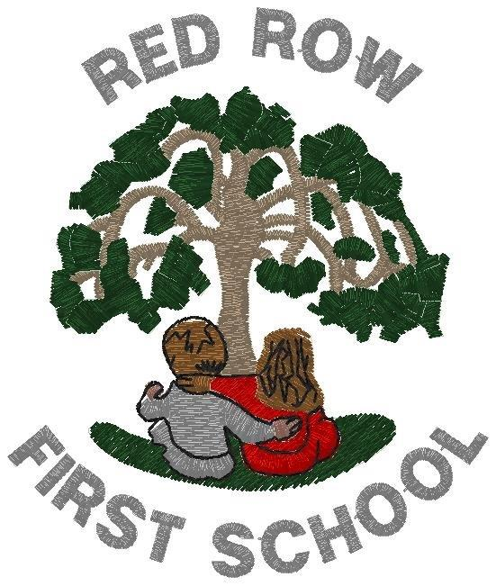
APPLICATION FOR A PLACE AT SCHOOL/NURSERY CLASS

ON COMPLETION OF THIS FORM. PLEASE RETURN IT TO THE SCHOOL OFFICE

- Name of Nursery Class/School Red Row First School

- Name of Child

- Date of Birth

- Home Address

- Home Telephone Number

- Mobile Telephone Number

- Parents Names

- Occupation (Full/Part Time)

- 30 Hours Entitlement Date of Birth National Insurance No

- Name and Address of GP

- Present School and Address ……………………………………………….
(Main school applications only)

- Please give details of any attendance at a playgroup, toddler group, etc (Nursery
Applications)
……………………………………………….

- Once a child is admitted to School/Nursery, regular attendance is expected.

- ‘Rising threes’ are children who are registered pupils at a school and have not reached the age of three but will do so before the end of their first term at school. We accept applications for children to start as soon as they turn 3.

Date Signature of Parent

